Work

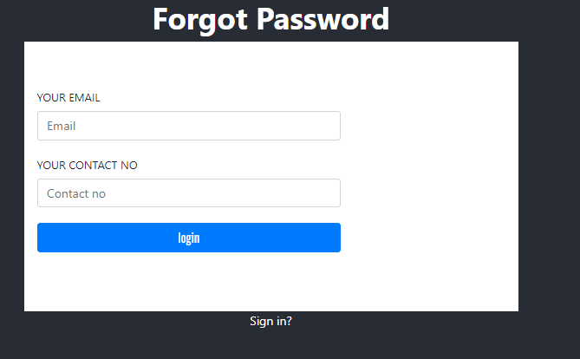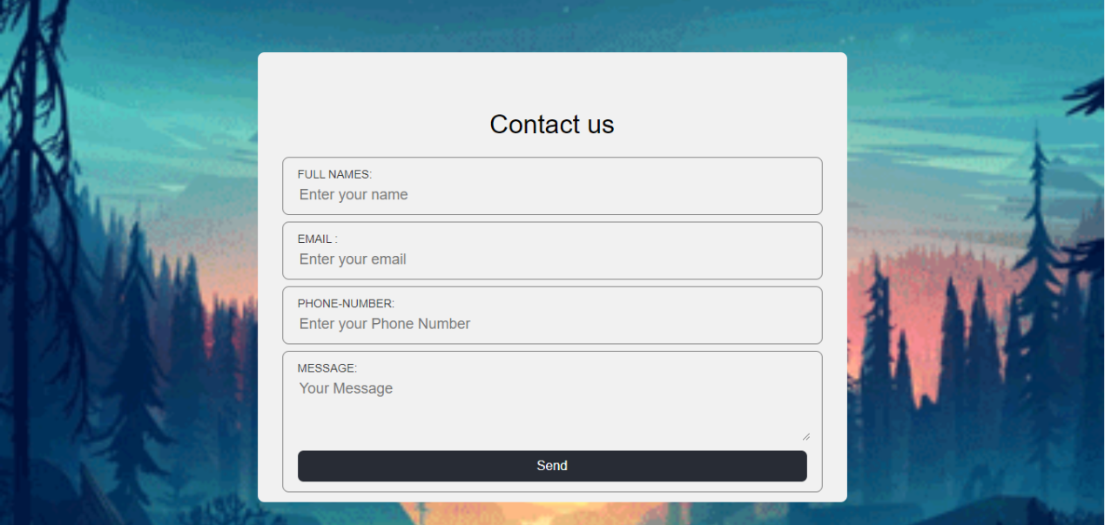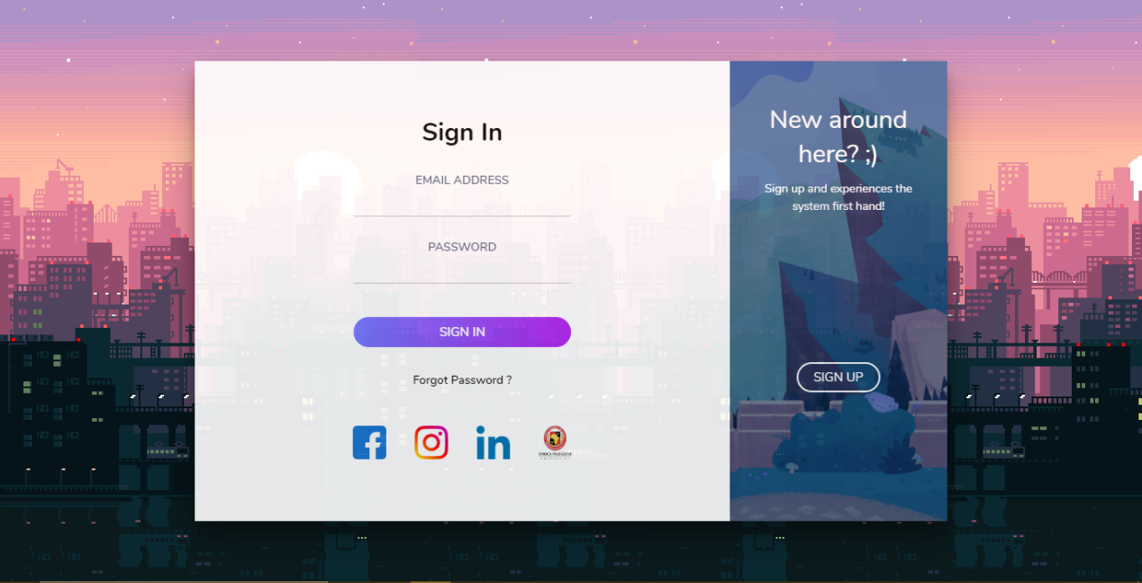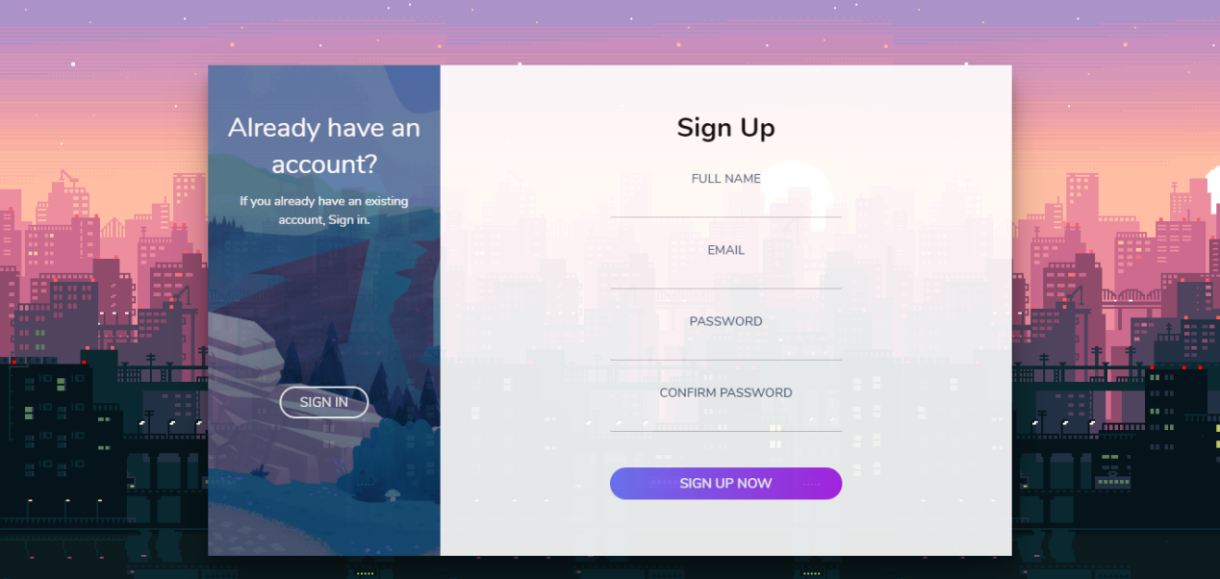

This is my progress, Login, Sign Up, Contact and forgot password page. I will add a little tweak into the login page. Keep in mind Contact and forgot your password page is a demo or sketch and it is **NOT** the final web-page/project because the design is too dull and moderate. I will work on the home website and try to finished up on the forget us and contact us page and submit them on the 17th of June